# AVIRAL SRIVASTAVA

# 4NI19IS018

# SECTION – A

**ASSIGNMENT 1**

# Continuous Integration and Continuous Deployment (CI/CD)

1. **What is CI/CD?**

CI/CD, which stands for continuous integration (CI) and continuous delivery (CD), creates a faster and more precise way of combining the work of different people into one cohesive product. In application development and operations (DevOps), CI/CD streamlines application coding, testing and deployment by giving teams a single repository for storing work and automation tools to consistently combine and test the code to ensure it works.

# What is Continuous Integration, Continuous Delivery, and Continuous Deployment?

CI/CD allows organizations to ship software quickly and efficiently. CI/CD facilitates an effective process for getting products to market faster than ever before, continuously delivering code into production, and ensuring an ongoing flow of new features and bug fixes via the most efficient delivery method.

# Difference between CI and CD

Continuous integration (CI) is practice that involves developers making small changes and checks to their code. Due to the scale of requirements and the number of steps involved, this process is automated to ensure that teams can build, test, and package their applications in a reliable and repeatable way. CI helps streamline code changes, thereby increasing time for developers to make changes and contribute to improved software.

Continous Delivery (CD) is the automated delivery of completed code to environments like testing and development. CD provides an automated and consistent way for code to be delivered to these environments.

Continous Deployment is the next step of continuous delivery. Every change that passes the automated tests is automatically placed in production, resulting in many production deployments.

Continuous deployment should be the goal of most companies that are not constrained by regulatory or other requirements.

# How CI/CD relate to DevOps?

DevOps is a set of practices and tools designed to increase an organization’s ability to deliver applications and services faster than traditional software development processes. The increased speed of DevOps helps an organization serve its customers more successfully and be more competitive in the market. In a DevOps environment, successful organizations “bake security in” to all phases of the development life cycle, a practice called DevSecOps.

The CI/CD pipeline is part of the broader DevOps/DevSecOps framework. In order to successfully implement and run a CI/CD pipeline, organizations need tools to prevent points of friction that slow down integration and delivery. Teams require an integrated toolchain of technologies to facilitate collaborative and unimpeded development efforts.

# Stages of CI/CD pipeline

The continuous integration/continuous delivery (CI/CD) pipeline is an agile DevOps workflow focused on a frequent and reliable software delivery process. The methodology is iterative, rather than linear, which allows DevOps teams to write code, integrate it, run tests, deliver releases and deploy changes to the software collaboratively and in real-time.

A key characteristic of the CI/CD pipeline is the use of automation to ensure code quality. As the software changes progress through the pipeline, test automation is used to identify dependencies and other issues earlier, push code changes to different environments and deliver applications to production environments. Here, the automation’s job is to perform quality control, assessing everything from performance to API usage and security. This ensures the changes made by all team members are integrated comprehensively and perform as intended.

The ability to automate various phases of the CI/CD pipeline helps development teams improve quality, work faster and improve other DevOps metrics.

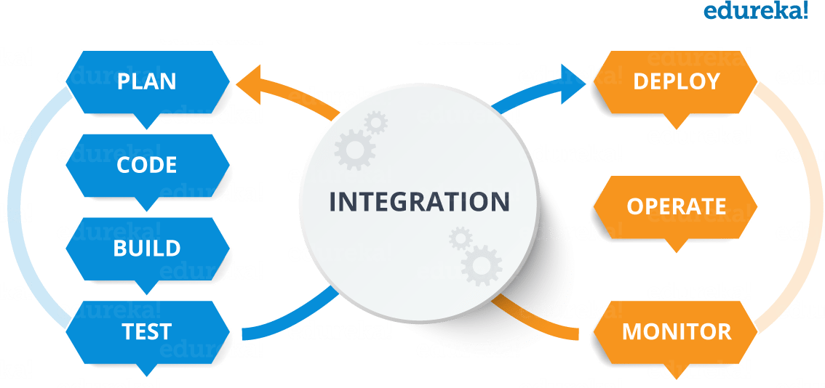

# CI/CD pipeline phases

From source code to production, these phases make up the development lifecycle and workflow of the CI/CD pipeline:

* **Build**: This phase is part of the continuous integration process and involves the creation and compiling of code. Teams build off of source code collaboratively and integrate new code while quickly determining any issues or conflicts.
* **Test**: At this stage, teams test the code. Automated tests happen in both continuous delivery and deployment. These tests could include integration tests, unit tests, and regression tests.
* **Deliver**: Here, an approved codebase is sent to a production environment. This stage is automated in continuous deployment and is only automated in continuous delivery after developer approval.
* **Deploy**: Lastly, the changes are deployed and the final product moves into production. In continuous delivery, products or code are sent to repositories and then moved into production or deployment by human approval. In continuous deployment, this step is automated.

# Implementation of CI/CD pipeline stages Plan

Propose a feature that needs to be built, or outline an issue that warrants change.

# Code

Turn use case suggestions and flowcharts into code, peer-review code changes, and obtain design feedback.

# Test

Verify code changes through testing, preferably automated testing. At this point, unit testing will usually suffice.

# Repository

Push code to a shared repository like Github that uses version control software to keep track of changes made. Some consider this as the first phase of the CI/CD pipeline.

# Set up an Integration Testing Service

For example, Travis CI to continuously run automated tests, such as regression or integration tests, on software hosted on services like Github and BitBucket.

# Set up a Service To Test Code Quality

Better Code Hub can help continuously check code for quality in CI/CD pipeline. This will enable the software development team to spend less time fixing bugs. Better Code Hub uses 10 guidelines to gauge quality and maintainability in order to future proof the code.

# Build

This might overlap with compilation and containerization. Assuming the code is written in a programming language like Java, it’ll need to be compiled before execution. Therefore, from the version control repository, it’ll go to the build phase where it is compiled. Some pipelines prefer to use Kubernetes for their containerization.

# Testing Phase

Build verification tests as early as possible at the beginning of the pipeline. If something fails, you receive an automated message to inform you the build failed, allowing the DevOps to check the continuous integration logs for clues.

Smoke testing might be done at this stage so that a badly broken build can be identified and rejected, before further time is wasted installing and testing it. Push the container

(Docker) image created to a Docker hub: This makes it easy to share your containers in different platforms or environments or even go back to an earlier version.

# Deploy the App, Optionally To a Cloud-Based Platform

The cloud is where most organizations are deploying their applications. Heroku is an example of a relatively cheap cloud platform. Others might prefer Microsoft Azure or Amazon Web Service (AWS).

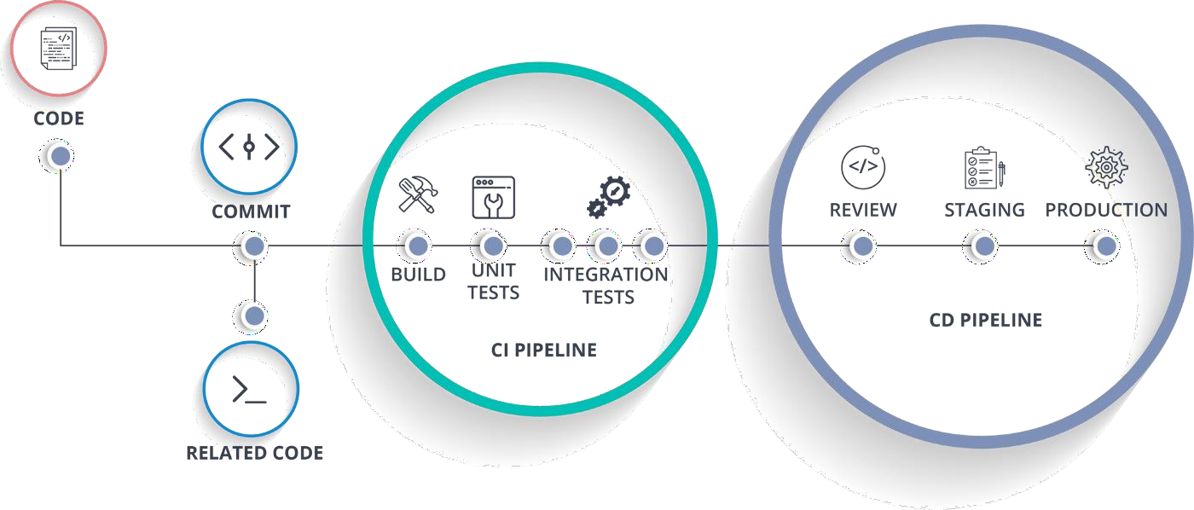

# Advantages of CI/CD pipelines

* Builds and testing can be easily performed manually.
* It can improve the consistency and quality of code.
* Improves flexibility and has the ability to ship new functionalities.
* CI/CD pipeline can streamline communication.
* It can automate the process of software delivery.
* Helps you to achieve faster customer feedback.
* CI/CD pipeline helps you to increase your product visibility.
* It enables you to remove manual errors.
* Reduces costs and labour.
* CI/CD pipelines can make the software development lifecycle faster.
* It has automated pipeline deployment.
* A CD pipeline gives a rapid feedback loop starting from developer to client.
* Improves communications between organization employees.